NAME 338

Ship Design Project and Presentation

by

Student Name

Student ID: 12344567

Submitted to the

Department of Naval Architecture and Marine Engineering, Bangladesh University of Engineering and Technology,

in partial fulfillment of the requirements for the degree of

BACHELOR OF SCIENCE

in

Naval Architecture and Marine Engineering



October 2024

Department of Naval Architecture and Marine Engineering, Bangladesh University of Engineering and Technology, Dhaka-1000, Bangladesh

Forwarding Letter

To

The Course Supervisor,

[Name of the Supervisor],

Professor,

Department of Naval Architecture & Marine Engineering,

Bangladesh University of Engineering and Technology (BUET)

Subject: Submission of Report on “[Project Title]”

Dear Sir,

We sincerely thank you for providing us with the opportunity to submit our report on “[Project Title].” Preparing this report has been a valuable learning experience, allowing us to gain deeper insights into the subject.

To complete the report, we conducted extensive research and referred to various sources, including books, online resources, and guidance from our esteemed teachers. We are deeply grateful for your support and direction throughout the process, which have been instrumental in completing this assignment.

We have strived to ensure the report is comprehensive and accurate. However, we kindly request your understanding for any unintentional errors and hope for your generous consideration.

Sincerely yours,

[Your Name]

Student No.: [Your Student Number]

[Co-author’s Name]

Student No.: [Co-author’s Student Number]

Level–Term– [Specify Level & Term]

Department of Naval Architecture and Marine Engineering

Bangladesh University of Engineering and Technology (BUET)

Table of Contents

1 Introduction 3

2 Owner’s Requirement 4

3 Route Specification 5

4 Basis Ship Selection 6

5 Principle Particulars 7

6 General Arrangement Plan 8

Section 1 8

7 Lines Plan 9

8 Hydrostatic Calculation 10

Section 1 10

Section 2 10

Section 3 10

Section 4 10

Section 5 10

9 Scantling Calculation 11

Midship Section Drawing 11

Longitudinal Construction 11

Shell Expansion 11

10 Weight Estimation 12

Section 1 12

Section 2 12

Section 3 12

Section 4 12

11 Stability Calculation 13

Section 1 13

Section 2 13

12 Trim Calculation 14

Section 1 14

13 Resistance Calculation 15

Section 1 15

Section 2 15

14 Propeller Design 16

15 Power Calculation 17

16 Rudder Calculation 18

Section 1 18

Section 2 18

17 Steering Arrangement 19

Section 1 19

Section 2 19

18 Engine and Gearbox Selection 20

Section 1 20

19 Engine Foundation 21

Section 1 21

Section 2 21

20 Shaft Arrangement 22

Section 1 22

Section 2 22

21 Health, Safety, and Environment 23

22 Economic and Financial Parameters 24

23 Ethics 25

24 Conclusion 26

25 References 27

List of Tables

Table 1: Principal particulars 7

List of Figures

Figure 1 : General Arrangement Plan 8

Preface

Provide a brief overview of the purpose and context of this document, including background information relevant to the project.

Objective

# 

Clearly state the primary objective of this project or report, including the goals and intended outcomes.

# Introduction

Insert text here. You can provide relevant references in your project.

You can provide citations using different formats. One example is shown.

In-Text Citations

When referring to the papers in the main text of your project, include the authors' last names and the publication year. For example:

According to Smith and Johnson (2020), ...

Recent advancements in ship hull optimization have demonstrated efficiency improvements (Lee et al., 2019).

**Example text:**

Smith and Johnson (2020) explored innovative hull designs for enhanced fuel efficiency in marine vessels. Their computational studies revealed that a bulbous bow configuration could reduce drag by up to 12%, highlighting the importance of hydrodynamic shape optimization.

Lee et al. (2019) focused on the application of composite materials in shipbuilding to improve structural integrity and reduce weight. Their research demonstrated that using fiber-reinforced polymers could decrease overall ship weight by 15%, translating to significant fuel savings.

Citations can be added to other chapters of the project according to their relevance.

# Owner’s Requirement

Insert text here

# Route Specification

Insert text here

# Basis Ship Selection

Insert text here

# Principle Particulars

Detail the main dimensions and characteristics of the vessel, such as:

* Length Overall (LOA)
* Beam
* Depth
* Draft
* Deadweight

Table 1: Principal particulars

| **Principal Particulars** | **Unit** | **Value** |
| --- | --- | --- |
| Length Overall (LOA) | m |  |
| Length Between Perpendiculars (LBP) | m |  |
| Beam (Breadth) | m |  |
| Depth | m |  |
| Draft | m |  |

# General Arrangement Plan

Insert text here

## Section 1

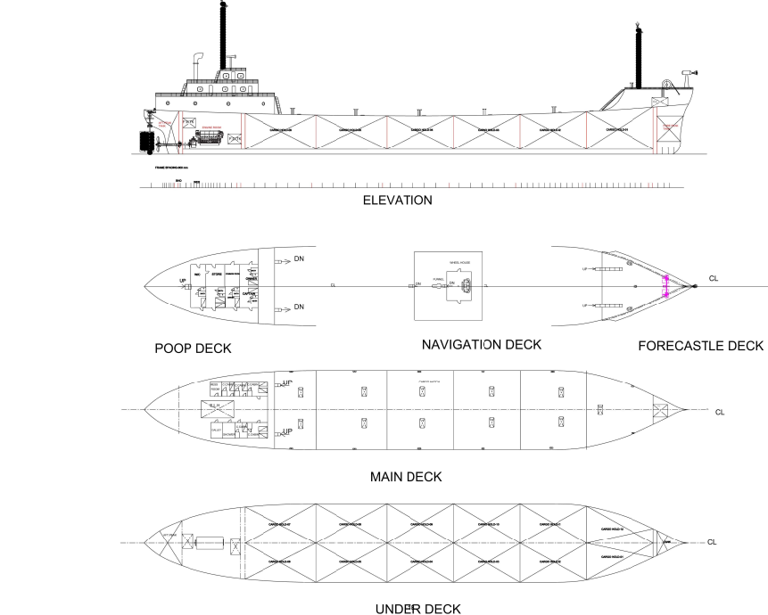

Figure 1 : General Arrangement Plan

# Lines Plan

Insert text here

# Hydrostatic Calculation

Insert text here

## Section 1

Insert text here

## Section 2

Insert text here

## Section 3

Insert text here

## Section 4

Insert text here

## Section 5

# Scantling Calculation

Insert text here

## Midship Section Drawing

Insert text here

## Longitudinal Construction

Insert text here

## Shell Expansion

Insert text here

# Weight Estimation

Insert text here

## Section 1

Insert text here

## Section 2

Insert text here

## Section 3

Insert text here

## Section 4

Insert text here

# Stability Calculation

## Section 1

Insert text here

## Section 2

Insert text here

# Trim Calculation

## Section 1

Insert text here

# Resistance Calculation

Insert text here

## Section 1

Insert text here

## Section 2

Insert text here

# Propeller Design

# Power Calculation

# Rudder Calculation

Insert text here

## Section 1

Insert text here

## Section 2

Insert text here

# Steering Arrangement

Insert text here

## Section 1

Insert text here

## Section 2

Insert text here

# Engine and Gearbox Selection

Insert text here

## Section 1

Insert text here

# Engine Foundation

Insert text here

## Section 1

Insert text here

## Section 2

Insert text here

# Shaft Arrangement

Insert text here

## Section 1

Insert text here

## Section 2

Insert text here

# Health, Safety, and Environment

Suggestions, including but not limited to the followings:

* List and explain all the health, safety, and environmental considerations made during the project.
* Describe how these considerations positively impact the environment and the shipbuilding sector.

# Economic and Financial Parameters

Suggestions, including but not limited to the followings:

* Extend your observation to comment on the economic feasibility of your designed vessel.

# Ethics

Suggestions, including but not limited to the followings:

* Include the ethical considerations addressed during the project.
* Explain the importance of these considerations from a ship design perspective.
* Describe how incorporating ethical considerations in ship design contributes to your professional growth as a naval architect.

# Conclusion

# References

1. Lee, H., Park, S., & Kim, Y. (2019). *Composite materials in shipbuilding: A study on weight reduction and performance enhancement*. Journal of Naval Architecture, 52(1), 89-102. https://doi.org/10.5678/jna.2019.7890
2. Smith, J., & Johnson, M. (2020). *Innovative hull designs for improved marine vessel efficiency*. Journal of Marine Engineering, 45(2), 123-137. https://doi.org/10.1234/jme.2020.4567